Jason Yao

CS 203

Ward

05/02/14

**Java Graphics Report**

**Introduction & Use**

The Java Graphics Poster is a program written in Java to gather an integer and a colour from a user, and then to use those values to change the graphics to output a customized movie poster.

The movie that the image is derived from is Ender’s Game, based on Orson Scott Card’s book. The movie was decent, and touched on a lot of themes that OSC touched on in the books. I Chose the elements because I’m a terrible drawer, and using polygons was the most efficient way for me to draw Ender, And I arranged the elements based on the poster, as shown below.

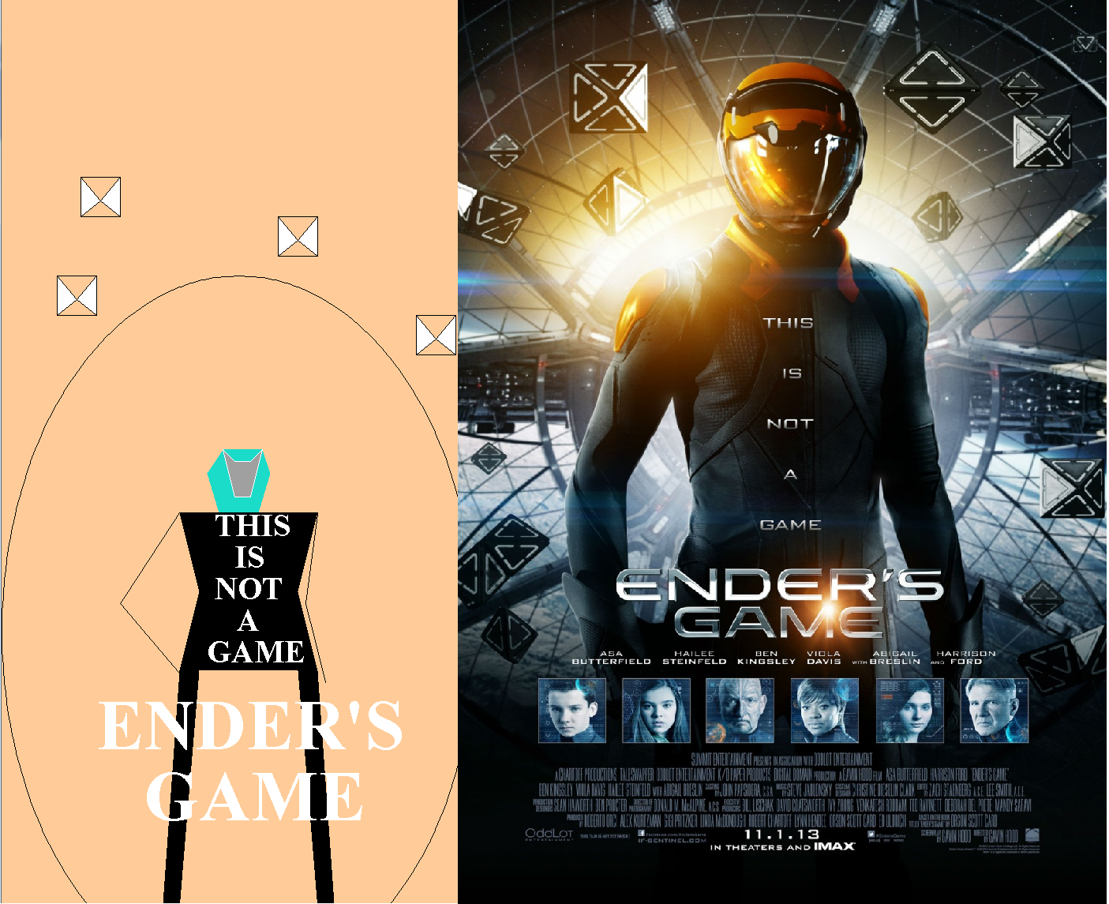

**Composition**

The elements chosen were a broad range, from ovals, specific polygons like cubes or a helmet. I chose those elements because those were the ones that were most similar to the original movie poster, which was also the reason why I arranged them in that particular fashion as well.

**Future Expansion**

Given more time, I would have made ender more defined, had multiple colours in his suit instead of just black, and would have tried to make him look more than a glorified stick figure.

In order to implement these changes, one would simply need to go through the bother of placing very specific points using the .addPoint() command, and simply have as many as possible in order to make the poster look good, with the more accurate points, the better looking the poster will be.

**Conclusion**

I’m very satisfied with the fact that I managed to draw more than a blob- coming from somebody who is almost definitely artistically challenged, I think I did a decent job drawing a person and not making that person look like a blob. The most challenging aspect of coding this program was making sure that all of the graphics were in the correct place, and to learn how to change the font when utilizing the drawString() command. I’ve learned to be very careful about how I place my initial points when drawing polygons, since if you add an extra 0 to the position of one of the pixels, it ends up filling in a polygon covering over half the page.